Sprint 1 - Endurance Design Document

October XX, 2019

***This document contains instructions and examples which are for the benefit of the person writing the document. All text in RED should be removed and replaced with information pertinent to your project***.

Text in the finalized document must be **BLACK**.

This is the System Design Document (SDD) and will include sections detailing system flow, algorithms, staffing plan, software/hardware, and Test Plan

You must complete all sections of this document.

Where required by the Sprint Checklist you must embed images of some artifacts in this SDD

To regenerate the TOC in Word, select all (CTL-A) and press F9.

**Table of Contents**

**1.** **EXECUTIVE SUMMARY 3**

1.1 Project Overview 3

1.2 Purpose and Scope of this Specification 3

**2.** **PRODUCT/SERVICE DESCRIPTION 3**

2.1 Product Context 3

2.2 User Characteristics 3

2.3 Assumptions 3

2.4 Constraints 3

2.5 Dependencies 4

**3.** **REQUIREMENTS 4**

3.1 Functional Requirements 5

3.2 Security 5

*3.2.1* *Protection 5*

*3.2.2* *Authorization and Authentication 6*

3.3 Portability 6

**4.** **REQUIREMENTS CONFIRMATION/STAKEHOLDER SIGN-OFF 6**

**5.** **SYSTEM DESIGN 6**

5.1 Algorithm 6

5.2 System Flow 6

5.3 Software 6

5.4 Hardware 6

5.5 Test Plan 7

5.6 Task List/Gantt Chart 7

5.7 Staffing Plan 7

# Executive Summary

## Project Overview

Describe this project or product and its intended audience or provide a link or reference to the project charter.

This project is about using robotics to complete a series of tasks. The intended audience is the classroom in which the project was given and specifically, my classmates/teacher. We also could use these robots to introduce new people into coding when everything is fully functional; once people see how cool and fulfilling it is to program robots to move in a controlled environment, we can attract more attention to software/computer programming.

## Purpose and Scope of this Specification

Describe the purpose of this specification and its intended audience. Include a description of what is within the scope and what is outside of the scope of these specifications. For example:

The intended purpose of this project is to follow a series of steps and processes given to us by our instructor. This includes:

* Following a rectangular path (with proper accuracy and an appropriate speed)
* Moving around in an infinity symbol like pattern (also trying to change color/talk to the user)
* Competing amongst our group mates and dodging obstacles in our robot’s path (Basically making a robot that is properly built for anything thrown at us)

# Product/Service Description

In this section, describe the general factors that affect the product and its requirements. This section should contain background information, not state specific requirements (provide the reasons why certain specific requirements are later specified).

The general factors that affect our product is the programming of the robot itself and how computers utilize this hardware. We also use the website Sphero.edu and a Bluetooth connection to run block code (to make the robot function the way we want). Our robots are in new models (Bolt), but overall, with proper computer/phone software, a Sphero robot, and a stable Bluetooth connection this project should be possible.

## Product Context

How does this product relate to other products? Is it independent and self-contained? Does it interface with a variety of related systems? Describe these relationships or use a diagram to show the major components of the larger system, interconnections, and external interfaces.

Our robots can be compared to other robot services/products, due to the simplistic nature of how easy it is to connect. There are many other robotic sites that come with purchasable robots/machines to control, however, the robots we are using, and the user interface run by Sphero.edu is a completely independent service. The website is run over Bluetooth connection and is very easy to use when a Sphero robot is present; the site they use as well Is their own in terms of the block code and doesn’t rely on other sites such as code.org.

## User Characteristics

Create general customer profiles for each type of user who will be using the product. Profiles should include:

* Student/Classmate – Ages – 18 – 23 – College Education Level – Software/Computer Science Expertise – First to second year work in robotics and programming.
* Teacher – Age (30 – 80) – Masters/Bachelors/PhD level Education – Software/Computer Science expert – Multiple years working in the field of robotics/software development.
* Regular consumer – Age (5 – 70) – Any education level – Any major/profession – New or existing knowledge of programming/software.

## Assumptions

List any assumptions that affect the requirements, for example, equipment availability, user expertise, etc. For example, a specific operating system is assumed to be available; if the operating system is not available, the Requirements Specification would then have to change accordingly.

Any of the following assumptions will affect the requirements, a little description to explain each can be used as help too.

* Use of a windows computer (This will not affect the robots’ capabilities, but the sensory data portion of Sphero.edu will be affected. It is easier to use this website/app on Mac)
* User Expertise (This will not be a complete deal breaker, any knowledge range can be used with the robot, but some functions/code will appear difficult and trying to make the robot complete a certain task will be harder with less knowledge)
* Chromebooks and iPad Devices can be used with the Sphero robots (Recommended that you use Windows computers or MacBook devices with the capabilities of ios14 and up)

## Constraints

Describe any items that will constrain the design options.

Items and reasons that can constrain the design options.

1. parallel operation with an old system (Ios 14 and below + windows 12 and below)
2. Room availability (The product will be unable to complete all asked tasks without proper preparation times. If we are unable to meet at least 3 times, the result will show)
3. Access to the Sphero Website, Unprofessional management, and Faulty security (All these factors will prohibit the best possible work achieved and if present can be detrimental)
4. Criticality of the application (If Sphero itself was to shut down or malfunction the work process can be affected)
5. System resources (Bad battery usage of our main computer, the failure to bring our work devices, and limited storage to store our documents)

## Dependencies

List dependencies that affect the requirements.

1. The workspace reception being quality enough to run the program code.
2. The Wi-Fi adapter/intel graphics cards of our computers (Having accessibility to Apple’s EN0, and mac OS software)
3. Having a robot designed by Sphero or a robot with the capabilities to run through the main website

# Requirements

* Describe all system requirements in enough detail for designers to design a system satisfying the requirements and testers to verify that the system satisfies requirements.
* Organize these requirements in a way that works best for your project. Describe every input into the system, every output from the system, and every function performed by the system in response to an input or in support of an output. (Specify what functions are to be performed on what data to produce what results at what location for whom.)
* Each requirement should be numbered (or uniquely identifiable) and prioritized.

**Priority Definitions**

The following definitions are intended as a guideline to prioritize requirements.

* Priority 1 – The requirement is a “must have” as outlined by policy/law
* Priority 2 – The requirement is needed for improved processing, and the fulfillment of the requirement will create immediate benefits
* Priority 3 – The requirement is a “nice to have” which may include new functionality

It may be helpful to phrase the requirement in terms of its priority, e.g., "The value of the employee status sent to DIS **must be** either A or I" or "It **would be nice** if the application warned the user that the expiration date was 3 business days away". Another approach would be to group requirements by priority category.

* A good requirement is:
* Correct
* Unambiguous (all statements have exactly one interpretation)
* Complete (where TBDs are absolutely necessary, document why the information is unknown, who is responsible for resolution, and the deadline)
* Consistent
* Ranked for importance and/or stability
* Verifiable (avoid soft descriptions like “works well”, “is user friendly”; use concrete terms and specify measurable quantities)
* Modifiable (evolve the Requirements Specification only via a formal change process, preserving a complete audit trail of changes)
* Does not specify any particular design
* Traceable (cross-reference with source documents and spawned documents).

## Functional Requirements

| **Req#** | **Requirement** | **Comments** | **Priority** | **Date Rvwd** | **SME Reviewed / Approved** |
| --- | --- | --- | --- | --- | --- |
| ENDUR_01 | Establish a Bluetooth/wifi connection | We need this in relation to controlling the actual robot and interacting with the main website. | First priority | 10/24/23 | 10/24/23 |
| ENDUR_02 | Having a Mac OS computer be our main source of operations | This is necessary due to access to the sensory data chart and for more conclusive evidence that our program runs smoothly. | Second priority | 10/25/23 | 10/26/23 |
| ENDUR_03 | More advanced type of robot and complete access to the course we will run our robot. | This is more of a want in our robotic project. We can work with any type of Sphero robot, but the entire process is made easier with more advanced robots. | Third priority | 10/27/23 | 10/29/23 |
| ENDUR_XX |  |  |  |  |  |

## Security

### Protection

Specify the factors that will protect the system from malicious or accidental access, modification, disclosure, destruction, or misuse. For example:

* encryption
* activity logging, historical data sets
* restrictions on intermodule communications
* data integrity checks

* Only group members can access and edit repository contents.
* Sphero must be within range of the host computer to operate remotely.
* Programs used for the system must be trusted and free of malware and whatnot.

### Authorization and Authentication

Specify the Authorization and Authentication factors.

* Each group member must accept the invitation to the proper repositories to be given permission to edit repository contents.
* Login confirms the identity of the person (with the correct username and the correct password) and grants access to the site under their respective username.

## Portability

If portability is a requirement, specify attributes of the system that relate to the ease of porting the system to other host machines and/or operating systems. For example,

* Percentage of components with host-dependent code;
* Percentage of code that is host dependent;
* Use of a proven portable language;
* Use of a particular compiler or language subset;
* Use of a particular operating system;
* The need for environment-independence - the product must operate the same regardless of operating systems, networks, development or production environments.

* The Sphero application provides its own block coding program.
* Each group member uses a different operating system.
  + Windows, MacOS, and ChromeOS are all compatible with Sphero.
* The course is an open track around the site of a rectangular room.
* Computers must connect with the robot and follow the block code effectively regardless of the operating system used.

# Requirements Confirmation/Stakeholder sign-off

Include documentation of the approval or confirmation of the requirements here. For example:

|  |  |  |
| --- | --- | --- |
| **Meeting Date** | **Attendees (name and role)** | **Comments** |
| 10/19/2023 | Jalen, Jared, Jimmy | confirmed all 2.5, 3, and 3.1 on SDD |
| 10/24/2023 | Jalen, Jared, Jimmy | confirmed to do, 3.1, 2.5, 3, and staffing plan on SDD |

# System Design

This section will provide all details concerning the technical design, staffing, coding, and testing the system

## Algorithm

Develop and describe here the algorithm that will be used to provide the required performance of your software

**Rectangle:**

* Roll 0 degrees at 38 speed for 6 seconds
* Roll 90 degrees at 39 speed for 3 seconds
* Roll 180 degrees at 38 speed for 6 seconds
* Roll 270 degrees at 39 speed for 3 seconds
* Roll 0 at 39 speed for 6 seconds

**Figure 8:**

* Speed 26
* Loop 1 time (spin 315 degrees for 2.8 seconds)
* Roll 315 degrees at 27 speed for 1.5 seconds
* Speed 26
* Loop 1 time (spin -315 degrees for 2.8 seconds)

## System Flow

Develop a flowchart (and show here) that accurately depicts how your software application will act to fulfill the algorithm. Embed your flowchart here.

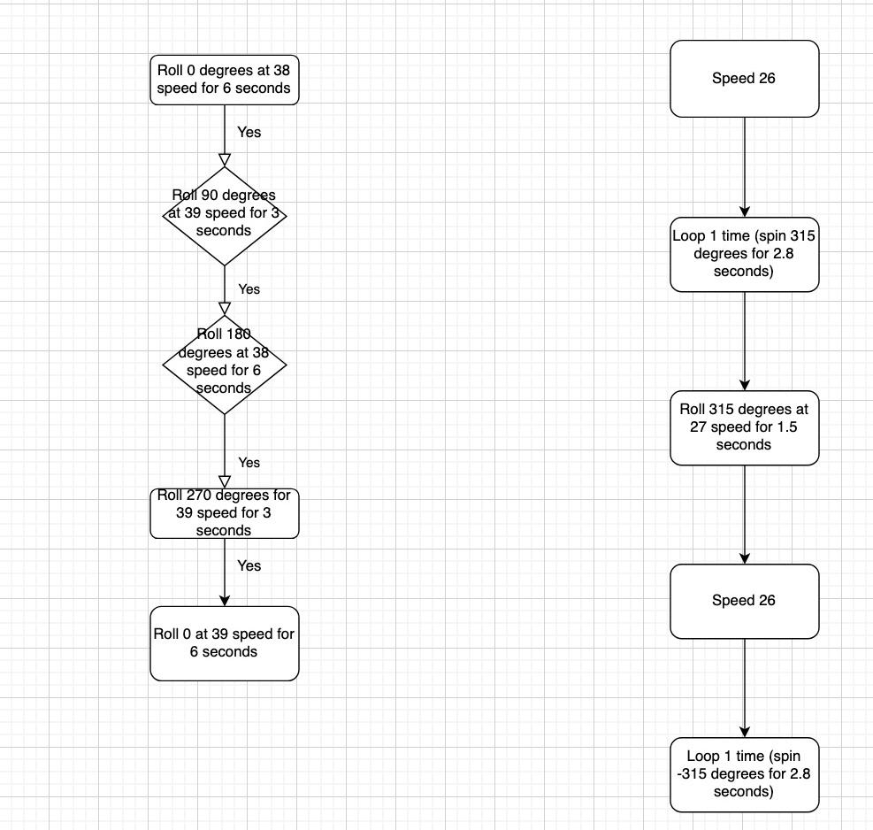

## Software

Describe software languages/platforms/api’s used to develop and deploy this application. Embed your block code here

Sphero 6.6.0 | Operates on Java | Written to give sphere-shaped robots the ability of motion by drawing paths through the app via block code.

## Hardware

Describe hardware platforms that were used to develop, test and demonstrate this application

MacBook Pro 15-Inch, 2019 | Processor 2.3 GHz 8-Core Intel Core i9 | Graphics Intel UHD Graphics 630 1536 MB | Memory 16 GB 2400 MHz DDR4 | MacOS Ventura 13.5.2

## Test Plan

Include a test plan showing all unit tests performed for this application, Include test rational, test date, staff member, pass/fail status

| **Reason for Test Case** | **Test Date** | **Expected Output** | **Observed Output** | **Staff Name** | **Pass/Fail** |
| --- | --- | --- | --- | --- | --- |
| Track ball forward |  |  |  |  |  |
| Track ball in rectangular pattern |  |  |  |  |  |
| Fix square pattern in our design |  |  |  |  |  |
| Lengthen the number of seconds to 6 from 3 |  |  |  |  |  |
| Trying to add stop feature |  |  |  |  |  |
| Trying to color coordinate all steps |  |  |  |  |  |
| Trying to fix color coordination |  |  |  |  |  |
| Trying to add speaking to our robot |  |  |  |  |  |
| Finally fixing speech and color system of our robot |  |  |  |  |  |

## Task List/Gantt Chart

Embed your gantt chart here

## Staffing Plan

Insert a chart/table that depicts the roles and responsibilities of each team member that worked on this project

| Name | Role | Responsibility | Reports To |
| --- | --- | --- | --- |
| Jalen | Project Manager | * Complete Gantt Chart * Complete Staff Plan, complete sprint 2 | Gantt Chart |
| Jimmy | Repository Host | * Hand in SDD * Complete sprint 3 | Repository |
| Jared | Programmer | * Requirements and requirements table * Complete sprint 1, portability * Sensory Data/Block Code | Sphero App |